Project Proposal

On

**College Application for its Activities and Notifications**



Module: STW300CEM Android Applications Development

Softwarica College of IT and E-Commerce

*Mahakavi Marg, Kathmandu 44600, Nepal*

Submitted By: Submittted To:

Pradip Kandel Kiran Rana

College ID: 160383 Ayush Mainali

Batch: 19 D Sujit Gyawali

Contents

List of Figures 3

1. Introduction 4

a. Project Introduction 4

b. Justification of the project 4

Background Study 4

Problem Statement 4

c. Description of the Project 5

Features of the project 5

2. Aims and Objectives of the Project 6

3. Development Methodology 7

a. Description of the Methodology 7

b. Design Pattern 7

c. System Architecture 8

4. Configuration Management 9

5. Prototyping 10

6. Conclusion 13

7. References 14

# List of Figures

Figure 1: Waterfall Methodology. 7

Figure 2: Three-tier client server architecture. 8

Figure 3: GitHub Folder Structure of the Project 9

# Introduction

## Project Introduction

Application on Android are rapidly growing all over the world as android devices are emerging day by day. So developing an android app will definitely have a good scope if the app has great usability. Today, often many colleges have their own app to share information between them. When any college have their own app, it makes them easy to deliver messages, notices and so many other things to each student. As android devices are now available in everyone’s hand, it makes it easy to know various information through the use of app. So college app for its activities and notifications is also an information sharing app that would make students know the information from the college in an easier and faster way. As it will be an android application, there is no problem in using this app as most of the students have android devices these days. Students need not require to visit college for knowing the notices and other information once they use this app as all the notices will be posted in the app. As the technology growing fast, we can implement technology in education field and this proposed application is also the part of implementing technology in education.

## Justification of the project

### Background Study

We all know that different activities and events are organized by the colleges in order to further develop the potential and skills of their students. Also, students get trouble in finding the learning materials or notices of the college. In this era of fast growing technology, we can implement technology in the field of education in order to make both the students and the college easier for sharing anything they want like notices, events, course details, and so on. This helps to save the valuable time of students in searching the reading materials, knowing the activities of colleges like workshops, seminars, events (sports and cultural activities), class routines, assignments, holiday updates, exam schedules, and so on and ultimately helps college to share student related resources more easily. Hence, development of an android application for any college has become important these days.

### Problem Statement

College application has a wide range of scope (in the education field) as use of technology has proven to be a better solution to many problems. Often colleges get many problems due to lack of application like this and hence they will surely use this type of system as it makes them easier to tackle with different problems. Many colleges now have developed systems like this and many are in the process of developing and some are still unknown about this system in the context of our country Nepal. In Nepal, only some reputed college have implemented this type of system. So to encourage college to use this type of system by briefing the advantages of this system is challenging in case of Nepal as we are not totally advanced to the era of technology yet. But if we explain the advantages of using this system to the administration of colleges, they will surely use this system as it will benefit them.

## Description of the Project

### Features of the project

Some of the most important features of the proposed project are given below.

* The application will have login and registration system for both teachers and students.
* Students will be able to get their academic performance details like exam results, assignments remarks through the use of this application.
* Students will be able view each modules contents and modules requirements from the application.
* Students will get notification about the different events organised by college like workshops, sports, cultural activities and so on.
* Placement information and internship opportunities will be posted in the system by teachers so that students can know the various opportunities.
* Students will be able to submit their assignments through the use of this application.

# Aims and Objectives of the Project

The ultimate aim of the proposed project is to help college to manage students’ data and their respective courses and to easily share files to the students.

Objectives

* To design a system for registering students and the respective module teachers.
* To implement login system for authenticating users (students and teachers).
* To provide the details of evets or activities (sports, cultural programs) and notices (assignments, holiday updates, exam schedules, regular class schedule) to the students through the application.
* To make it easy for students to submit their assignments through the use of application.
* To make students alert about regular class sessions, assignments deadlines and so on.

# Development Methodology

## Description of the Methodology

There are a lot of different methodologies for system development. In this project I am going to use Waterfall methodology.

Waterfall method is a classical method of system development used to create software system in linear or sequential approach. It is called so because the model develops systematically from one phase to another in downward fashion. This model is divided into different phases and previous phase must be completed in order to go to next phase. I have chosen waterfall approach in this project because all features or requirements of this project are clearly defined and also this is a short project and if requirements are changed during the development process, it may be difficult to complete the project on specified time. (The Economic Times. 2019)

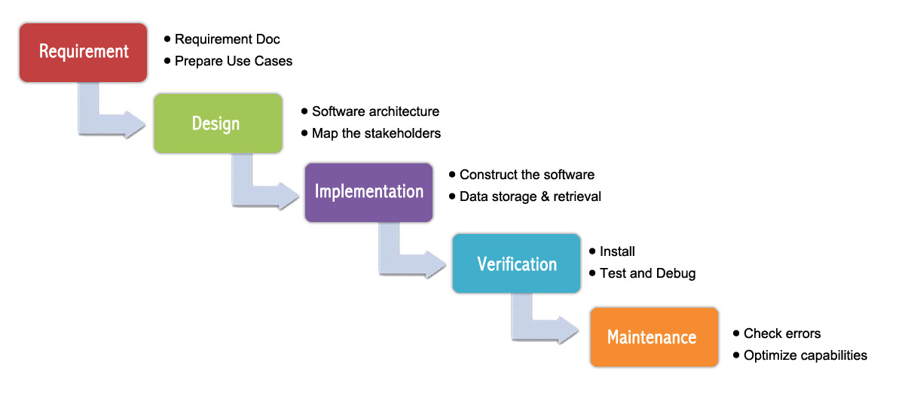

Figure 1: Waterfall Methodology.

## Design Pattern

Any project becomes more manageable and more maintainable when there is a use of some design pattern. Design pattern makes the code structured and easy to find bugs if present. So, in this project is am going to use **MVC (Model View Controller) pattern**. MVC pattern is such a pattern in which the system is divided into three parts from the developer perspective. View is one that is presented to the user, controller is one that controls the activities that the user do and model is one that helps to make communication between view and controller. The reason behind using MVC pattern in this project is that it helps to make the code module so that finding bugs and debugging them will be easier and faster.

(What is model-view-controller (MVC)? - Definition from WhatIs.com WhatIs.com. 2019)

## System Architecture

A conceptual model that defines the structure of a system is defined as system architecture. This aid in understanding how the system will behave. My project is totally based on **client-server architecture**. Client server architecture is such architecture in which the clients request for a service to service providers called servers and server response to their request. **Three-tier architecture** is client-server architecture which will be used in my project. In this architecture, we divide the system into three categories namely presentation tier (user interface), application tier (business logic) and data tier (data storage logic).

#### 

Figure 2: Three-tier client server architecture.

(3-tier system architecture - Google Search, 2019)

# Configuration Management

The proposed project will be pushed to GitHub and its folder structure would look like in the following figure.

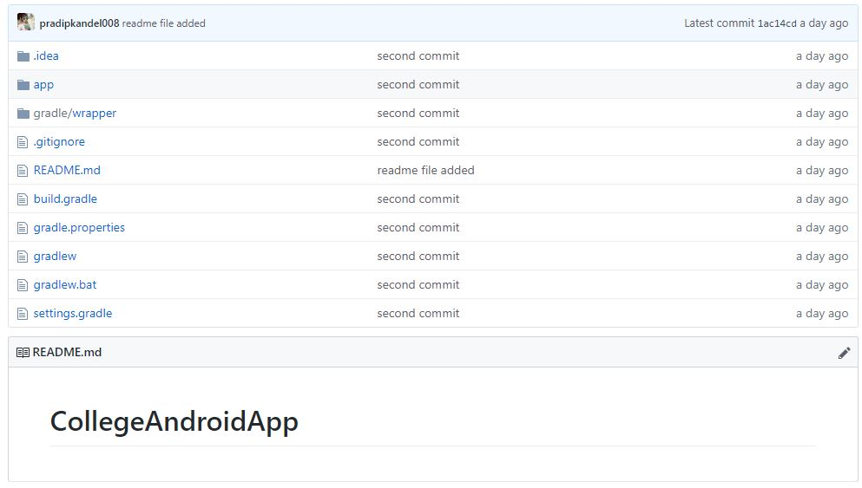

Figure 3: GitHub Folder Structure of the Project

**(**pradipkandel008/CollegeAndroidApp**, GitHub.**2019).

As shown in the above figure, the whole project will be uploaded or pushed to GitHub. The use of GitHub helps to control the versions of the project and removes the consequences that may appear due to loss of code. So GitHub works as backup for the proposed project.

# Prototyping

The initial prototypes of some of the features of the proposed project are given below:

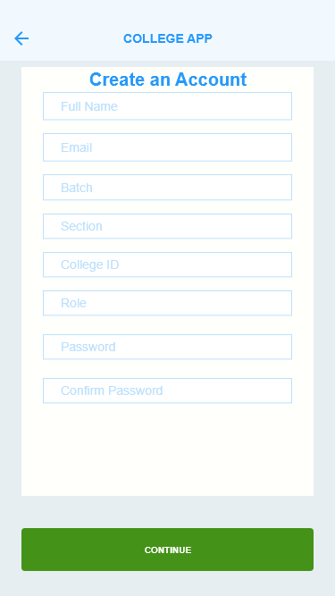 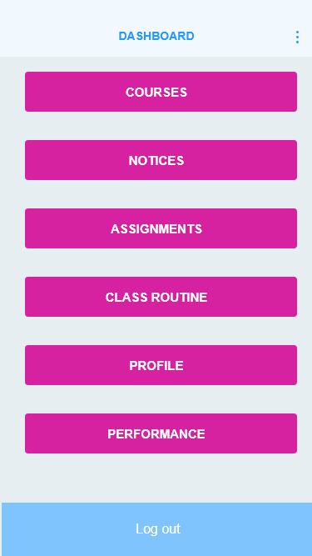

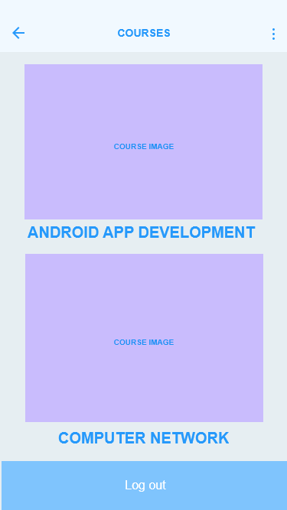 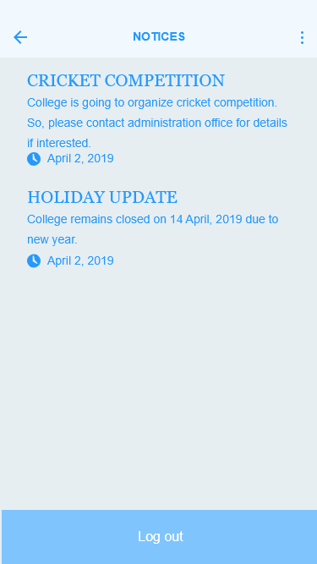

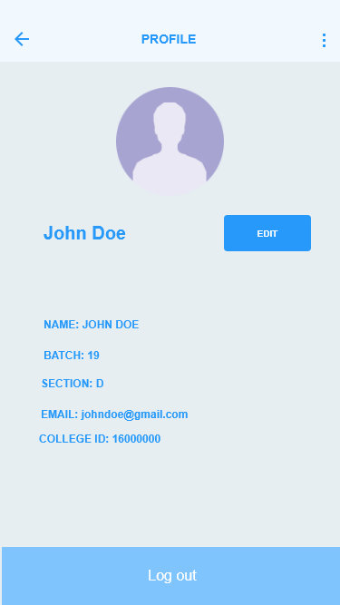

# Conclusion

The proposed project is College app for its activities and notifications and it will be android based project. The main aim of this app will be to deliver messages to the students from the colleges in an easier and faster way. This app will have a simple user interface and light weight. The proposed app has a wide range of scope (of course in education field) and has high usability. The app will be developed in about 2 months of time and is expected to meet the requirements.

# References

#### Google.com.np. (2019). 3-tier system architecture - Google Search. [online] Available at: https://www.google.com.np/search?q=3-tier+system+architecture&source=lnms&tbm=isch&sa=X&ved=0ahUKEwjmtI_wv5zcAhVKcCsKHZyjCNAQ_AUICigB&biw=1366&bih=662#imgrc=qEN_py9XBfj8SM: [Accessed 10 Apr. 2019].

pradipkandel008/CollegeAndroidApp GitHub. (2019). *pradipkandel008/CollegeAndroidApp*.

[online] Available at: https://github.com/pradipkandel008/CollegeAndroidApp [Accessed 10 Apr. 2019].

The Economic Times. (2019). *Definition of Waterfall Model | What is Waterfall Model ? Waterfall Model Meaning - The Economic Times*. [online] Available at: https://economictimes.indiatimes.com/definition/waterfall-model [Accessed 08 Apr. 2019].

What is model-view-controller (MVC)? - Definition from WhatIs.com WhatIs.com. (2019). *What is model-view-controller (MVC)? - Definition from WhatIs.com*. [online] Available at: https://whatis.techtarget.com/definition/model-view-controller-MVC [Accessed 09 Apr. 2019].